DC Monitoring

Direct Current (DC) is a current flow that is usually going in one direction. Batteries are the most common and easiest to understand example of DC in action, mobile phones, laptops and automobile batteries can produce DC. Batteries can accept charge or be discharged. For charging, current will flow in a particular direction, and for discharging, the current will flow in the opposite direction. 'Forward current' might be used to describe the current flow during typical operation of a device, and 'reverse current' might be used to describe the atypical state.

Alternating Current (AC), for comparison, typically alternates between positive and negative voltage, or forwards and reverse current, tens or hundreds of times a second. Just like how 'AC' can be used casually to means alternating voltage, DC can also be used to mean continuous positive or negative voltage, although it's usually prefixed with a V, as in +1.5VDC.

Direct Current (DC) measurement is also called DC sensing.

First, the two main types of DC sensing will be introduced. Then, the safety aspects of DC sensing, which are more significant than in AC measurement.

To monitor DC, a method has to be chosen from two main categories of technology - shunt monitors and hall effect sensors.

Shunt Monitoring
The first method uses the current sense resistor, or shunt. These are typically low resistance, specially designed metal-alloy resistors, which maintain a fairly consistent resistance value over a wide temperature range.

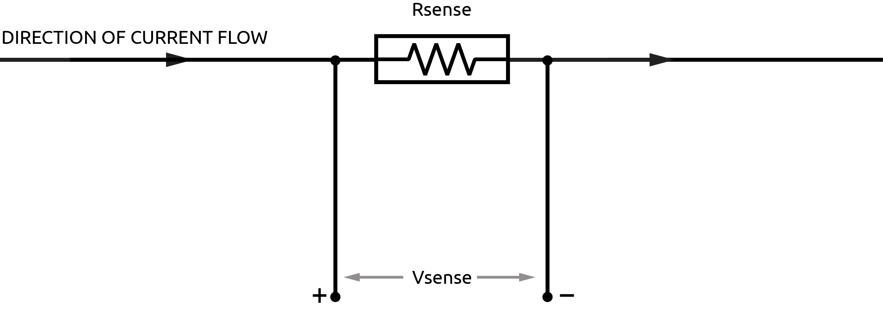
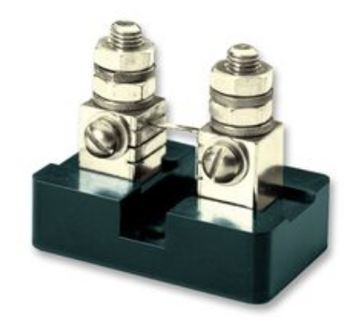
In this simple model, current flows through the shunt resistor and a small voltage is produced across it. The voltage drop is proportional to the current flow. Vsense is typically in the millivolt range. Many shunts are specified at a particular current range for a 50 or 100 mV sense output.

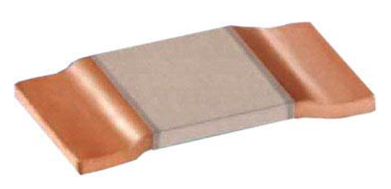

Soldered PCB Mounted Shunt. Credit: Ohmite Panel Mounted Shunt. Credit: Murata Manufacturing
(around 50A Max, around 2cm wide) (around 500A MAX, up to around 100mm wide)

The next step is to amplify the millivolt signal coming from the shunt resistor. To select an amplifier we must understand high-side and low-side current sensing.

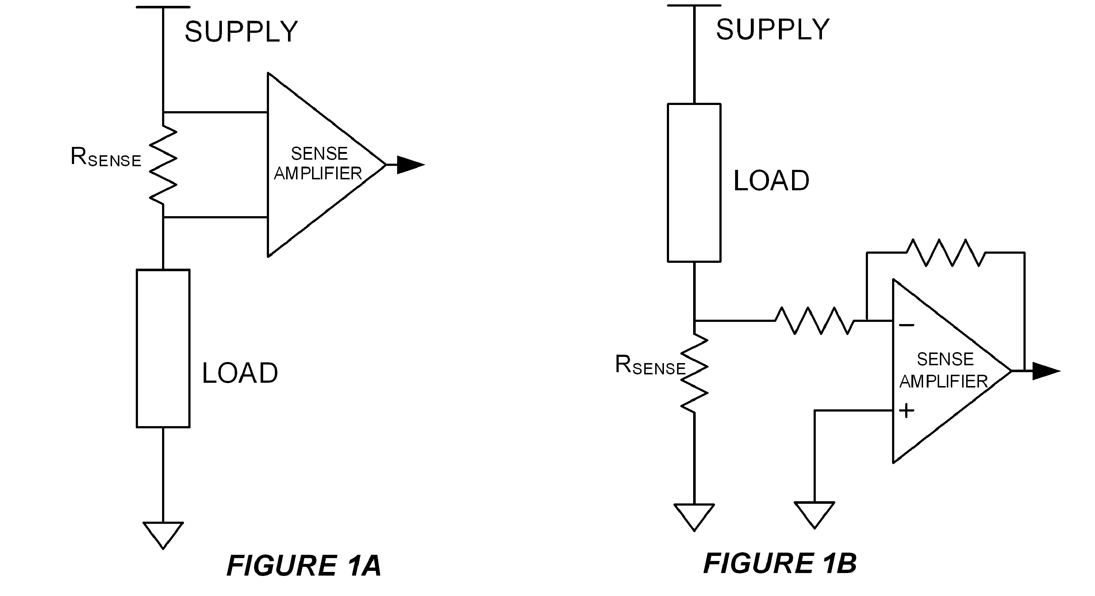Credit : User ElectronS at https://electronics.stackexchange.com/
In figure 1A we have high-side sensing, and in 1B low-side sensing. Low-side has the advantage of cheap circuitry and simple implementation. However the load circuitry may be sensitive to an offset ground voltage cause by the small resistance of the sense resistor which has been located between the other circuitry and ground, i.e. the load is not connected directly to ground.
High-side allows the load circuitry to be directly connected to ground, but requires a differential common-mode amplifier. This is an amplifier can can accept signals at or above the amplifier's supply voltage. When the common-mode input voltages are above the amp's supply voltage, this is described as over-the-top sensing. High-side sensing also has the advantage of short-circuit detection. Look again at the diagram, and you can see that if a short-circuit fault appeared in a low-side configuration, it would not be detected, whereas in the high-side configuration it would.

The main advantages of shunt based sensing are versatility, current range, and accuracy.

Hall Effect Sensing
Hall effect sensing takes advantage of the magnetism produced by the current in a conductor. A small magnet is used to divert a tiny proportion of the flow of charge sideways from the main current conductor, or transversely to the magnetic field. The hall effect itself is the voltage being produced in the second conductor, it was discovered by Edwin Hall in 1879.

Hall effect sensors are always small integrated circuits (ICs) that are very compact, ensuring the main current path comes in close proximity to the Hall magnet. Heat dissipation can be a problem because of these small integrated silicone packages. Therefore, hall effect current sensors tend not to measure above the range of 50Amps, although 200A sensors are now available.
The resistances are typically very low, and are referred to as 'Rsense' just like shunts.

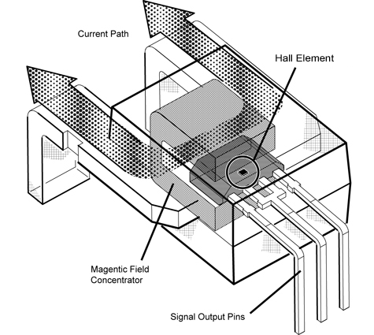High current Hall Effect current senson. Source: “https://www.allegromicro.com/en/Design-Center/Technical-Documents/Hall-Effect-Sensor-IC-Publications/Integrating-Hall-Effect-Magnetic-Sensing-Technology-Into-Modern-Household-Appliances.aspx”

Hall effect sensing has the advantage of common-mode isolation, that is, isolation from the high-side positive voltages of the primary conductor. In the safety section to follow this will be described in more detail. It also has the advantage of simplicity. The disadvantages are accuracy over temperature range, current range limitation and lack of versatility, sensitivity to magnetism, and cost.

Summery
There are a wide range of ICs that are capable of both shunt resistor and hall-effect based sensing.
A very wide range of shunt-based monitoring methods exist, the outline given above is for what is dubbed 'classic' high-side method. A wide range of methods are shown in Linear Technology's Application Note AN105.
http://www.analog.com/media/en/technical-documentation/application-notes/an105fa.pdf

Safety
To follow are several safety notes, all of which are much more apparent with DC monitoring than with AC. The shunt or hall effect IC will be referred to below as the 'sensor'.

Floating voltages:
Sometimes referred to as floating supply or floating ground, these are a major danger of any DC generation system and must be properly understood to protect people and equipment from injury and damage! An example of a floating ground is a non-earth solar PV array.
In a typical array we can expect voltage such in in the diagrams below:
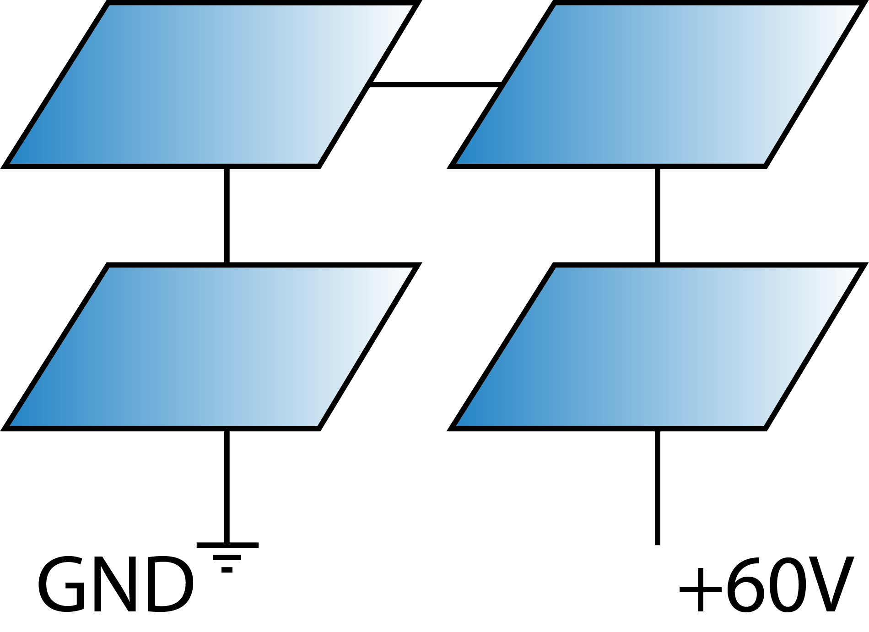Figure 2A
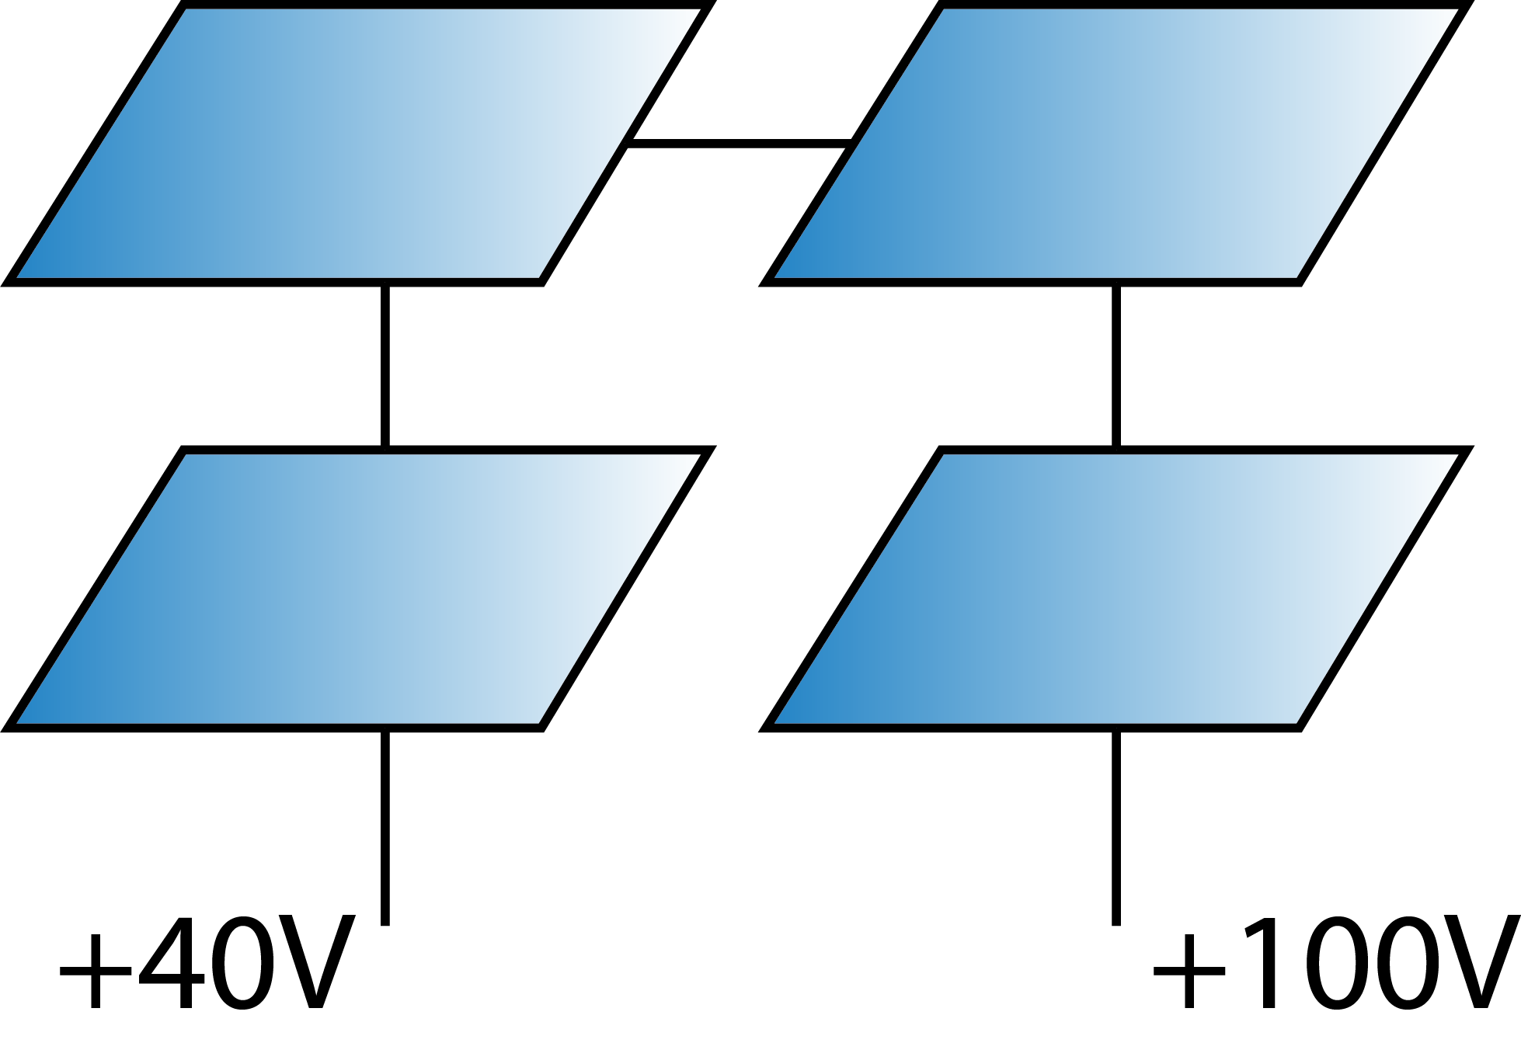Figure 2B
In figure 2A we have a safe system that's grounded to earth potential.
In figure 2B a fault has arisen and the ground has floated to +40VDC above actual earth, also, the high-side rail has gone too +100VDC. These could go higher!
What's particularly dangerous about this situation is that the metal in the system can be acting and a charge bank, meaning the available current is the generator + batteries (if any) + charge buildup. So although +40VDC isn't a great deal, the available current is. If an earth device was connected to a floating system such as in Figure 2B, a huge amount a current would probably destroy the device(s) instantly and potentially start fires.

In essence, any DC generation system where actual earth is available, a stake should be driven into the ground and connected to a single point of the system, typically near the battery if there is one.
Hardware designed for these potential problems must be either properly earth or double-insulated.
At the level of electronics design, hardware can incorporate isolated switching power supplies and isolated data connections for safer operation.

Cables:
Unlike AC measurement, DC measurement requires that cables are physically installed/cut/altered to accommodate the sensor. If we come back to our first diagram:
Rsense must exist in the main current path. The cable must be mounted either side of the shunt:
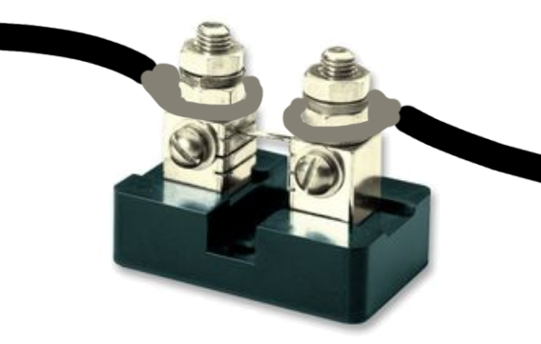

Heat:
The shunt resistance (Ohms) and heat dissipation rating (Watts) must be selected according to the expected maximum nominal Current (Amps). The shunts value can't be selected solely on it's Peak Current rating. Be sure to do your P=I²R calculations!
A ready-made calculator can be found here:
https://docs.google.com/spreadsheets/d/1AWvydOCWHVhTkWPqWinTKVM8Qdhd0ycmwWtvUQ2X24o/edit?usp=sharing

High-side isolation:
The sensor might exist at a typical voltage of 60V and have a huge amount of current available behind it, like in large solar arrays or even small battery systems. Care has to be taken to isolate the supply voltage from ground during integration of a DC monitor.

